**Emergency Ventilator**

Pre-clinical evaluation

Issue/change record

|  |  |  |  |
| --- | --- | --- | --- |
| Issue | Date | Author | Reason of issue/summary |
| 0.A | 10/04/2020 |  | DRAFT, released for ongoing development |
|  |  |  |  |
|  |  |  |  |
|  |  |  |  |
|  |  |  |  |
|  |  |  |  |

Contents

Introduction 3

1 Method of evaluation 3

2 Therapy validation 3

2.1 Intended use 3

2.2 Clinical risks 3

2.2.1 Toxic, allergenic substances 4

2.2.2 Oxidative stress 4

2.2.3 Lacking humidification 4

2.2.4 Cross-contamination 4

2.2.5 Barotrauma 5

2.2.6 Volutrauma 5

2.2.7 Rheotrauma 5

2.2.8 Atelectasis and atelectotrauma 5

2.2.9 Traumatic pneumothorax 5

2.2.10 User skill/error 5

2.2.11 Secretion 5

2.2.12 Non-evidenced therapy 6

2.2.13 Ineffectively implemented/delivered therapy 6

2.2.14 Breathing circuit deadspace (rebreathing) 7

2.2.15 Ineffective exhaust (rebreathing) 7

2.2.16 Bystander injury 7

2.3 Patient trial result 7

3 Technical safety and performance validation 7

3.1 Technical implementation of Pressure Controlled SIMV 7

3.2 Flow pressure waveforms 8

3.3 Technical risks 8

3.4 User instructions 8

3.5 Production quality assurance 8

3.6 Packaging 8

4 Conclusion 9

# Introduction

This document contains the technical, usability and clinical evaluation of the Emergency Ventilator.

# Method of evaluation

The physiological outcomes resulting from Pressure Controlled SIMV ventilation, when combined with blood gasses and vital signs monitoring, are well described. This is reflected in the choice of method for evaluating the Emergency Ventilator.

The pre-clinical evaluation is divided into two sections.

Section 2 introduces the clinical background and references established scientific literature, already affirming the efficacy Pressure Controlled SIMV. The section also identifies and addresses the clinical hazards associated with mechanical ventilation.

Section 3 is a device specific technical evaluation against the defined treatment and treatment specific safety parameters. This section makes reference to the technical validation and risk evaluation contained in ventilator’s design dossier.

Lastly, Section 4 concludes on the ventilator’s ability to meet clinical efficacy and safety.

# Therapy validation

## Intended use

Mechanical ventilation is indicated when the patient's spontaneous breathing is inadequate to maintain life. In general, mechanical ventilation is used to support the correct blood gasses and reduce the work of breathing. Mechanical ventilation provide assistance for breathing. It does not in itself treat the patients underlying ailment or disease.

The ventilator operates in conventional Pressure Controlled SIMV (Synchronised Intermittent Mandatory Ventilation) mode of ventilation only. It is intended for use with adult and young adult patients from 50kg and upwards. It interfaces with intubated, unconscious and semi-conscious, patients; and it interfaces with pressure ventilation masks on conscious patients.

The ventilator is designed for a simplified clinical protocol that demands minimal training and re-training. The gas cycling operation is designed to minimise oxygen consumption, to strictly what the patient requires. For purpose of simplicity, the I:E ratio (Inspiratory-Expiratory) is fixed 1:2. Inspiration flow rate fixed 60L/min, which produces an IP rise time of about 0.45s into a 600mL lung. The ventilator is intended for patients for whom this meets their therapeutic needs.

The general operating environment are hospitals and temporary healthcare facilities. Although the device is suitable for intra-hospital transport (moving patient between hospital departments, while being ventilated), it is not classed as a transport device. It is not designed for road or air transport.

## Clinical risks

Although mechanical ventilation may prevent hypoxia or hypercarbia, resulting from a patient’s respiratory failure, it can also be damaging to the lungs.

The generic hazards related to the mode of treatment, and their initiating root causes, are illustrated here by a device independent fault tree. The initiating root causes are indicated by the boxes shaded in grey. The analysis considers the clinical hazards that are inherent in the ventilator, and excludes those inherent in the combination devices and medicines.

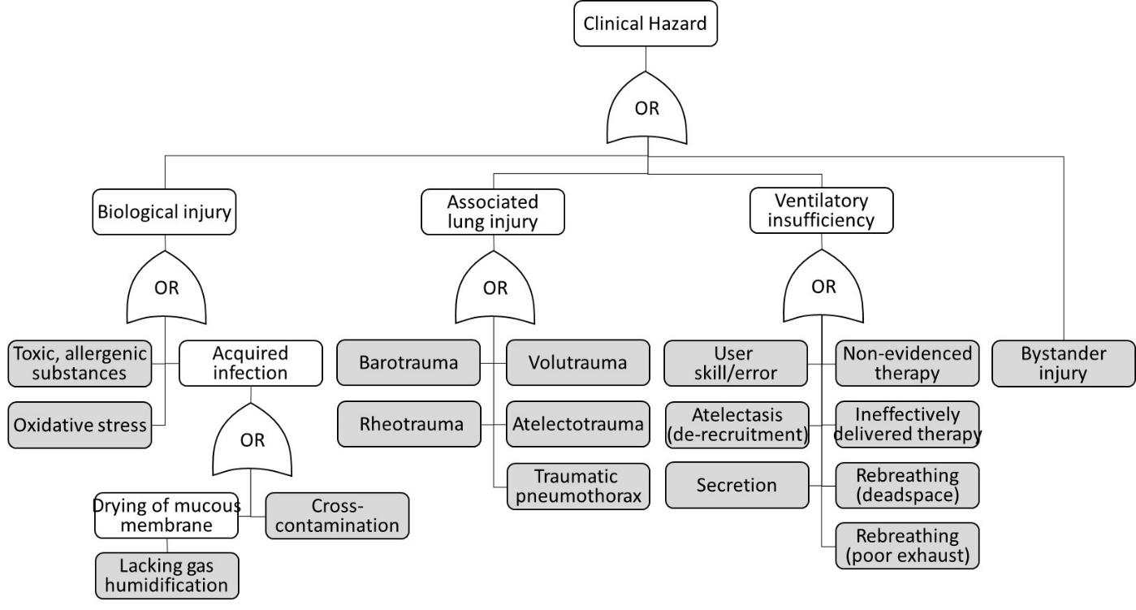

The initiating causes (boxes shaded in grey above) are addressed as follows:

### Toxic, allergenic substances

This occurs from biologically incompatible substances entering the patient gas, either from the external gas supply system or from ventilator components.

It is recommended that the gas supply is medical grade and is monitored. The ventilator is designed for all components in the gas part being cleaned from any process substances.

### Oxidative stress

This occurs when high concentrations of oxygen is delivered for a prolonged period of time. Oxygen is prescribed as a drug and it is the clinician’s responsibility to prescribe it prudently. The recommended technical system features monitoring to ensure that the prescribed concentration of FiO2 is being delivered, to an accuracy of 3% v/v.

### Lacking humidification

It is recommended that a combination gas humidification device is used. See the User Instructions.

### Cross-contamination

When the ventilator is used with an infectious patient, it is recommended to use a qualified bacteria on the exhaust port. The 22mm exhaust may also receive an adapter for connecting it to a scavenging system. See the User Instructions.

### Barotrauma

The tension stress from an absolute pressure and/or shear stress on tissue that transmits a pressure can cause ruptures at the alveolar level.

The maximum inspiratory pressure (IP) is limited to 35mbar and the ventilator cuts gas supply at 40mbar. Although there is no generally accepted pressure at which there is no risk of barotrauma, the pressure range is comparably lower to other marketed ventilators. The risk of barotrauma is considered to be acceptably mitigated.

### Volutrauma

Can occur by two mechanisms. 1) The tidal volume is inappropriately high, over-distending the lung as a whole; or 2) The tidal volume appears appropriate, but is disproportionately distributed to a recruited sub-part of the lung only. This can happen as result of a partial lung obstruction (e.g. by secretion) or from atelectasis (de-recruitment) in another part of the lung.

The maximum inspiratory pressure (IP) is limited to 35mbar. Although volutrauma can occur at 35mbar, standard clinical protocols advise clinicians to use the minimally necessary IP that achieves the desired blood gasses. Awareness and monitoring can acceptably manage the risk of volutrauma.

### Rheotrauma

Similar to barotrauma, but where the stresses result from high gas flows.

The ventilator flow rate is limited to 60L/min, is comparably lower to the capabilities of other marketed ventilators.

### Atelectasis and atelectotrauma

This relates to the alveoli collapsing between the breaths and lung tissue becoming is subject to mechanical shear stress when the lung is prised open. This can result in an inflammatory response or tissue damage.

The ventilator has an adjustable end-expiratory pressure (EP) which can be set to prevent the alveoli collapsing. It is recommended to use TcCO2 or EtCO2 monitoring, in which a decline in CO2 elimination would indicate atelectasis. See User Instructions.

### Traumatic pneumothorax

An acute lung injury resulting from a pressure or flow ‘blast’, or from a significant over-distention of the lung.

The ventilator is limited to 40mbar maximum pressure. It has dual independent shutdown mechanisms, to prevent that any form of ventilator failure could result in a sporadic pressure spike.

### User skill/error

The User Instructions defines the skill and responsibilities of the ventilator operator. The design has been simplified, to specifically lower the required user skills level.

Ventilator usability is subject to validation by the clinician testing.

### Secretion

When a portion of alveoli are obstructed by secretion, then the lung function is reduced. It can also contribute to volutrauma, by the mechanism described in section 2.3.6 above.

It is recommended to monitor CO2 elimination and O2 saturation. A decline in any of these measures could indicate excessive secretion, which must be removed by suctioning. This is a standard practice in ventilation.

### Non-evidenced therapy

Pressure Control SIMV is a well-known therapy dating back to the 1970’s. Accompanying this document are 2 example clinical review papers which demonstrate the clinical efficacy of Pressure Controlled invasive ventilation, including in the treatment of acute lung injury (ALI) or acute respiratory distress syndrome (ARDS). The papers acknowledge subtle differences between Pressure Controlled and Volume Controlled ventilation, but they do not identify any differences in patient outcomes of length of hospital stay.

1. Chacko B, *et al*. Pressure-controlled versus volume-controlled ventilation for acute respiratory failure due to acute lung injury (ALI) or acute respiratory distress syndrome (ARDS). Cochrane Database of Systematic Reviews 2015, Issue 1. Art. No.: CD008807. DOI: 10.1002/14651858.CD008807.pub2.
2. Garnero AJ, *et al*. Modos controlados por presión versus volumen en la ventilación mecánica invasiva. Med Intensiva. 2013;37:292-8. Study co-authored by Hospital Universitario del Henares, Coslada, Madrid.

Practically all currently marketed advanced ventilator feature Pressure Controlled SIMV modes of ventilation, including with volume control entirely disengaged, matching the clinical function of the present ventilator.

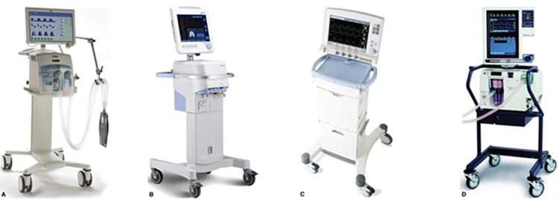

Examples of leading advanced ventilators that feature Pressure Controlled SIMV modes of ventilation. These advanced ventilators can operate with or without volume monitoring. The advanced ventilators of course also feature Volume Control and combination modes, which are above the function of the present ventilator. Their inclusion of Pressure Controlled SIMV nonetheless demonstrate its clinical validity.

### Ineffectively implemented/delivered therapy

The risk is that the implemented pressure-flow profile is sub-optimal and does not make the gas exchange happen properly – i.e. the pressure plateau is too short or the tidal volume is insufficient, or EP is too high for the alveoli to fully empty.

Clinical protocols say that patients need between 4ml/kg and 8ml/kg volume (i.e. between 300ml and 600ml for a 75kg IBW person). This is a very wide range. Ventilation is therefore an output driven therapy. Blood CO2 level and O2 saturation are the outcomes. No one looks at a patient and prescribes a final volume or pressure. In practice, in Pressure Control ventilation, the clinician will start with a mid-range pressure. Then measures the blood gasses, which tells if there is a need to increase or decrease the pressure.

Of course, no one would want the pressure to result in so much volume that it over-stretches the lung (volutrauma). But no one would want to achieve a volume at any pressure either (barotrauma).

Another risk is that the ventilator inadequately synchronises with the patient’s spontaneous effort, resulting in Increased work of breathing or patient stress from ‘fighting’ the ventilator.

Both gas exchange and synchronisation are subject to validation by the patient trail.

### Breathing circuit deadspace (rebreathing)

It is recommended to use a conformity assessed breathing circuit. See User Instructions.

### Ineffective exhaust (rebreathing)

This has been subject to technical validations (see below) and is further subject to validation by the patient trail.

### Bystander injury

The ventilator is conformity assess to the EC Medical Device Directive 93/42/EEC with regards to the safety and health of users or other persons coming into contact with the ventilator.

## Patient trial result

To be completed.

Verify ability to maintain blood gasses (data or image of CO2 and O2 monitored values).

Verify patient comfort with the spontaneous breath synchronisation.

Describe conclusion of patient trial here, including any limitations.

Reference a competent clinical opinion.

# Technical safety and performance validation

## Technical implementation of Pressure Controlled SIMV

The present ventilator operates in Pressure Controlled SIMV (Synchronised Intermittent Mandatory Ventilation) mode of ventilation only. The mode secures a set number of breaths per minute, by firstly attempting to synchronize the mechanical delivery of breaths with patient’s spontaneous efforts. If the patient fails to spontaneously take a needed breath, then the ventilator delivers it mandatorily.

The ventilator reschedules the mandatory breath that follows a successfully synchronized spontaneous breath by 1 second. This is in anticipation that the patient will also instigate the following breath and to prevent a ‘fight’ between the patient and the ventilator.

SIMV behaves as PSV (Pressure Support Ventilation, including with reduced IP) when the patient makes full efforts, and it behaves as CMV (Continuous Mandatory Ventilation) if the patient does not make any efforts. When used with a mask on a conscious, spontaneously breathing patient, the SIMV behaves as nPSV or Synchronised BiPAP (by setting IP low). Switching the IP cycle off (or setting it equal to PEEP) makes SIMV behaves as CPAP (whether the patient is intubated or has a mask interface).

See User Instructions for the ventilation parameters.

## Flow pressure waveforms

Insert images and measurement data here, to demonstrate the proximal flow and pressure waveforms.

Obtain a competent clinical opinion on the waveshapes.

## Technical risks

Hazards related to the device technical system (component failure etc.) are mitigated by technical design. Device design dossier contains conformity assessments that evidence the ventilator meets requirements to European Medical Device Directive 93/42/EEC and the IEC 60601 (ISO 80601) series of standards on basic safety and essential performance of electrical medical equipment.

Risk Evaluation conforming to ISO 14971 on risk management of medical devices concludes that all known hazards are identified and their associated risks are reduced to acceptable levels. This conclusion relates to essential requirements for device safety, in respect of all current medical device standards.

See the design dossier.

## User instructions

Contains the details specified in IEC 60601 (ISO 80601) series of standards, including warnings and precautions regarding residual risks.

## Production quality assurance

See Production and Testing Specification in the design dossier, which outlines the response to production quality assurance requirements defined in the European Medical Device Directive 93/42/EEC.

## Packaging

Packaging is specified to preserve and contain the ventilator during various modes of transport.

# Conclusion

The Emergency Ventilator, subject to the user responsibilities and attention to the warnings described in the User Instructions, meets requirements for clinical efficacy and safety.